**Create and Locate Anchors – Android Java**

**Step 1: Connect Android Device to Android Studio**

Enable Developer Option in your Android Phone and connect it to PC using USB cable.

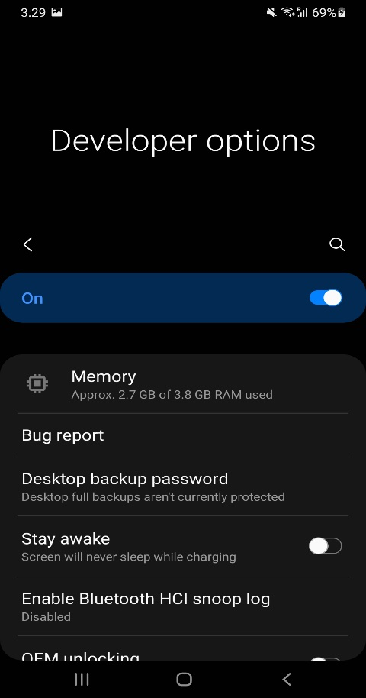

Open Android Studio **>** click on the emulator’s option **>** Click on your Android Device connected using USB cable.

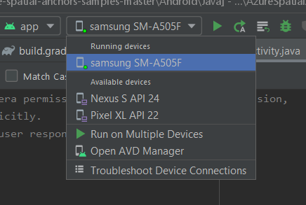

**Step 2: Enter all credentials of Spatial Anchor account to the android application code**

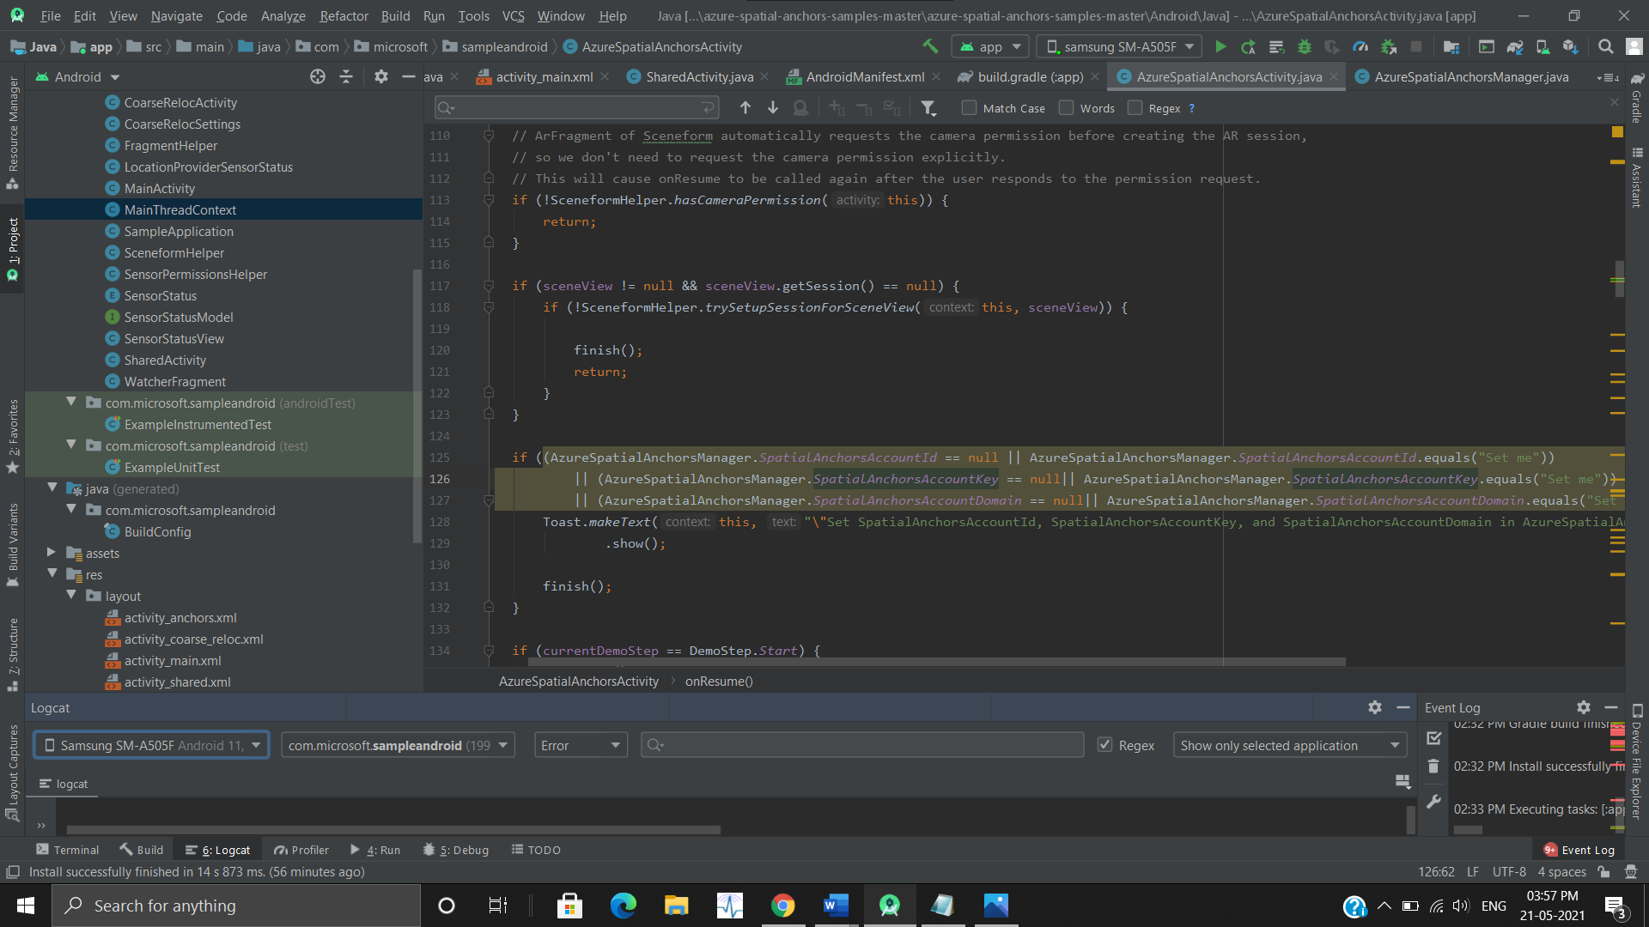

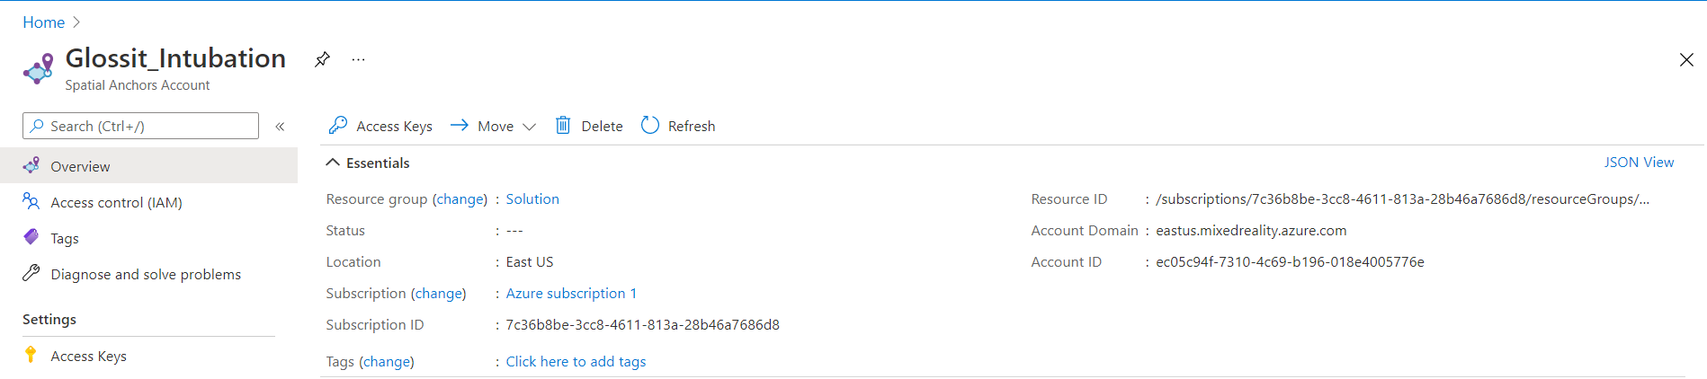

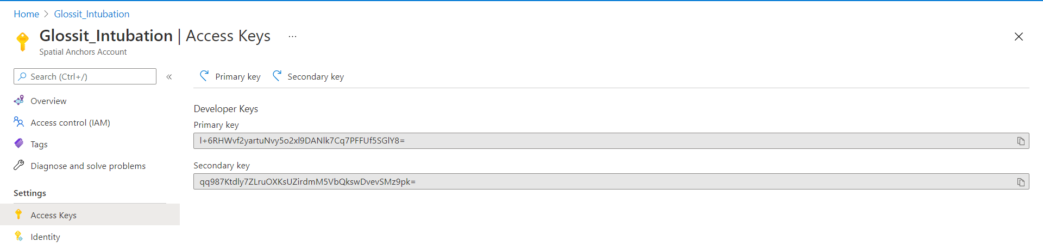

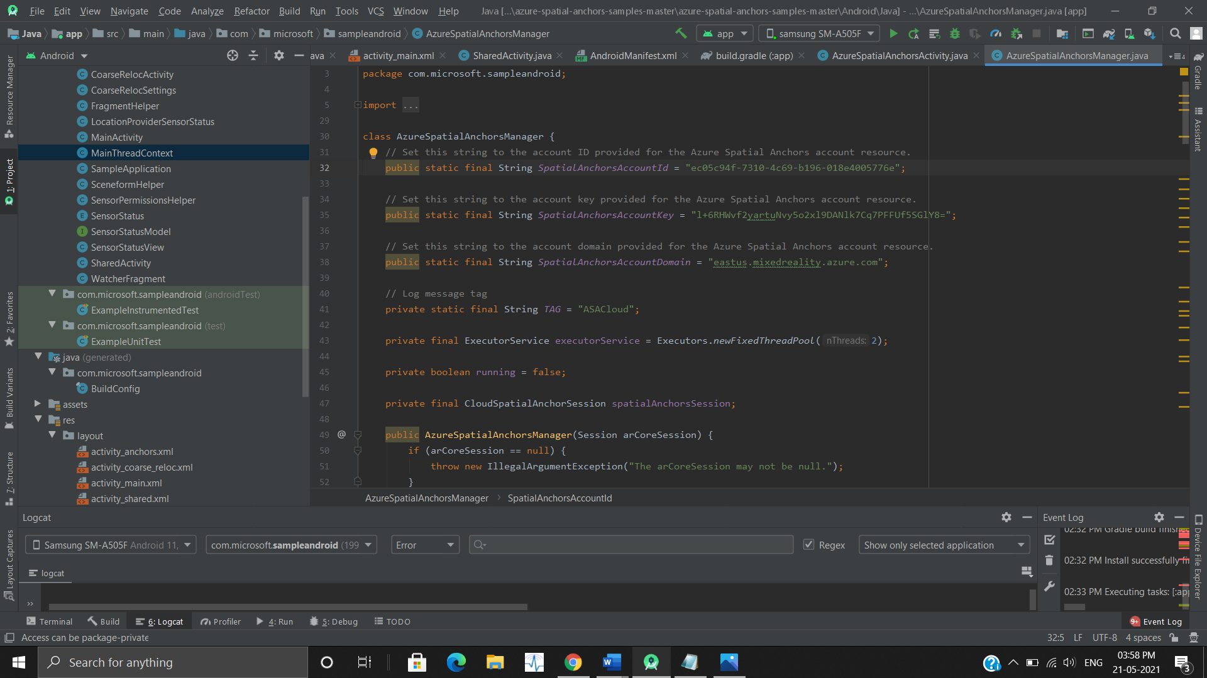

**Step 3: Run the application**

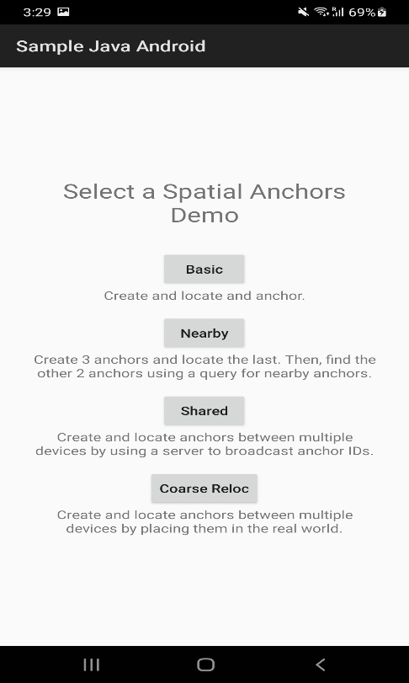

**Step 4: Click Basic button from mobile application to create and locate anchor**

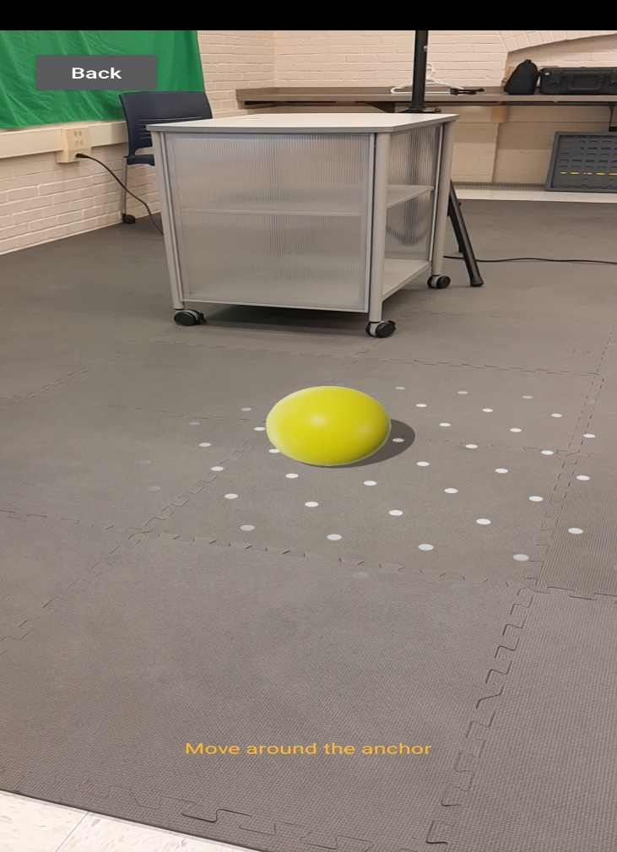

**Step 5: Log in to Microsoft Azure account to access the Spatial Anchors activity.**

